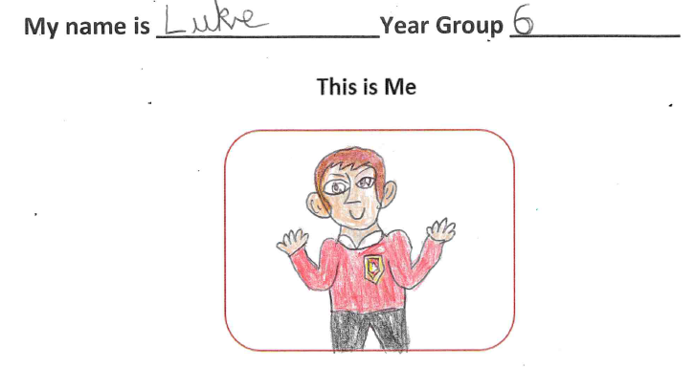
Why I wanted to be an EARA member?
I wanted to be an EARA member because when I saw the come up in school, I immediately knew it was for me. I wanted everyone to be treated as equals and to show that you can be anything you want to be, no matter gender stereotypes. Since then, I have learnt a lot about equality and equity and about the UNCRC. My favourite right is -Article 2 – All children have these rights no matter their differences are – because that is what I joined EARA for.

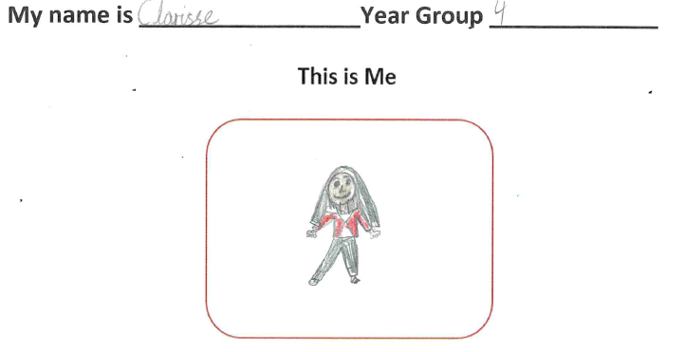
Why I wanted to be an EARA member?
I wanted to be an EARA member because I strongly believe that every child has the right to have their own thoughts and religion. I also believe that every child has the right to have an identity.

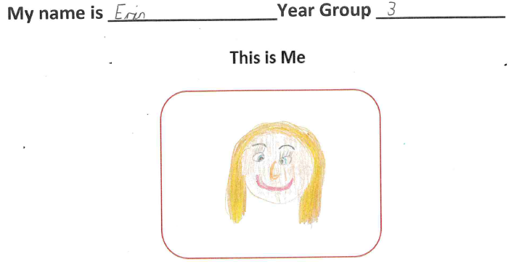
Why I wanted to be an EARA member?
I wanted to join EARA because it gives us a voice in school life and helps make things fair for children. I also wanted to hear other children’s voices and ideas.

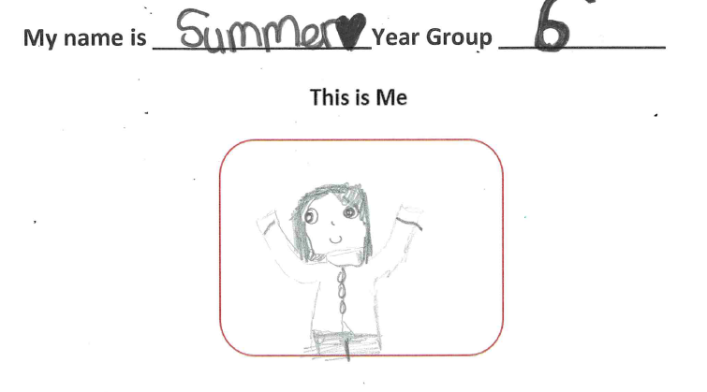
Why I wanted to be an EARA member?
I wanted to join EARA to spread kindness and equality, but also to stop people from being unkind to one another. Sometimes we have lessons about our rights, and I have learnt that unfortunately, some children are less fortunate than others and do not have the following: Article 3 – Adults must do what’s best for me – and this makes me sad. Being an EARA member will give me the opportunity to learn about my rights!

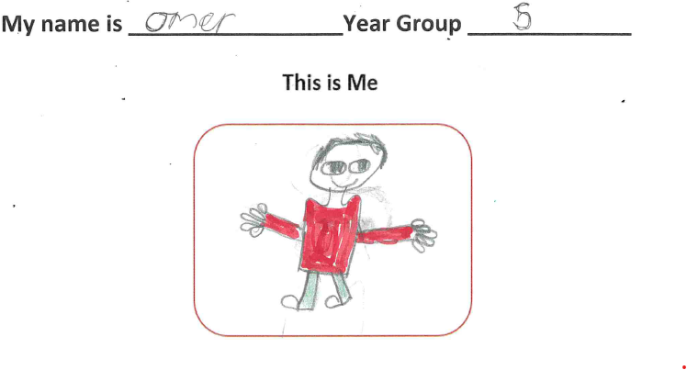
Why I wanted to be an EARA member?
It is important to me because we learn all about our rights. In particular, Article 9 – I have the right to have a family that keeps me safe and Article 11 – I have the right to be protected from being hurt or badly treated. We learn our rights and how to promote them based on the UNCRC. I am excited to also be able to help other people in this role.

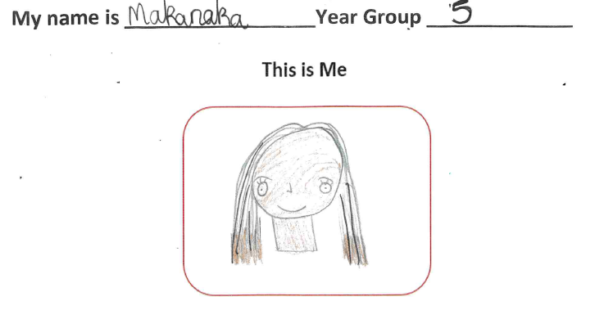
Why I wanted to be an EARA member?
I wanted to be an EARA member because I care for children’s rights in life. That is why I wanted to join EARA. For example – Article 7 states that I have a right to a name and a country.

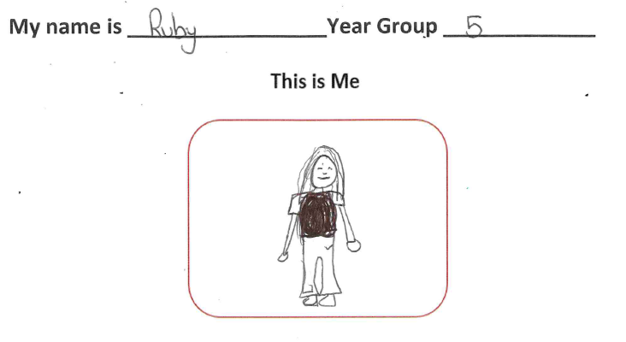
Why I wanted to be an EARA member?
I wanted to stand up for what is right so that we can all live happy lives and make sure everyone is treated with respect and in the same way as everyone else. It also gives us a voice that people will listen to and helps to make sure there is no discrimination.

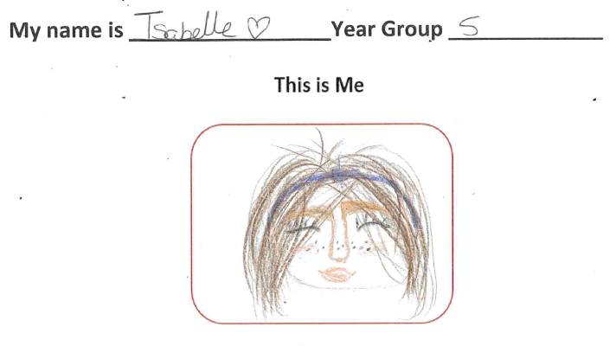
Why I wanted to be an EARA member?
I wanted to be an EARA member because I wanted to make sure everyone is part of a community. I also wanted to make sure people feel they are treated fairly and are cared for.

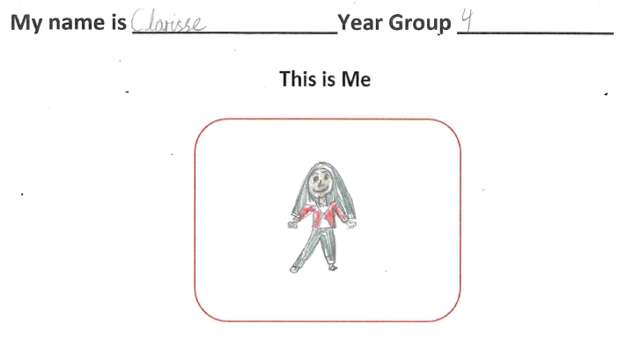
Why I wanted to be an EARA member?

I wanted to be an EARA member because I strongly believe every child has the right to have their own thoughts and religion. I also believe that every child has the right to have an identity.

My name is Ashraf Year Group Year 3

Why I wanted to be an EARA member?
I wanted to join EARA because I would like to help make our school a kinder and more positive place for everyone to learn. Being part of EARA gives me the opportunity to have a voice within the school community and to use it in a meaningful way. I am keen to contribute ideas and actions that will help Hatch Warren continue to grow as a supportive and inclusive school for everyone.

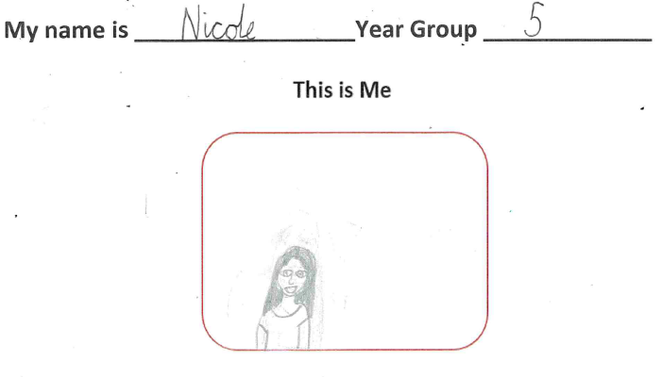
Why I wanted to be an EARA member?
I wanted to help people know their rights as a child. For example, I have the right to an Education. This means no one can stop anyone from growing and learning.

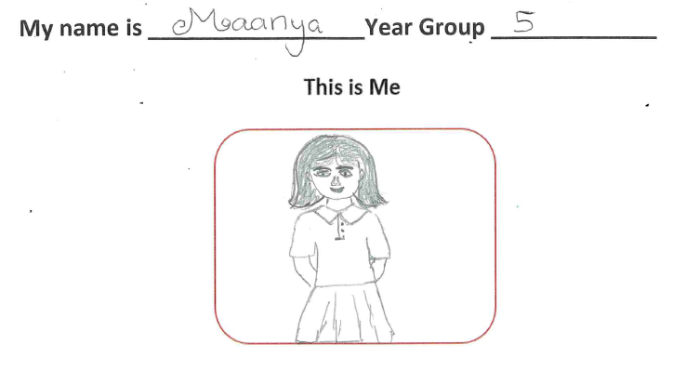
Why I wanted to be an EARA member?
I wanted to join EARA as it gives us a voice in school life and helps create a positive and respectful school to learn in. I have learned about Article 2 – All children have rights, no matter what their differences are. I feel very strongly about his.

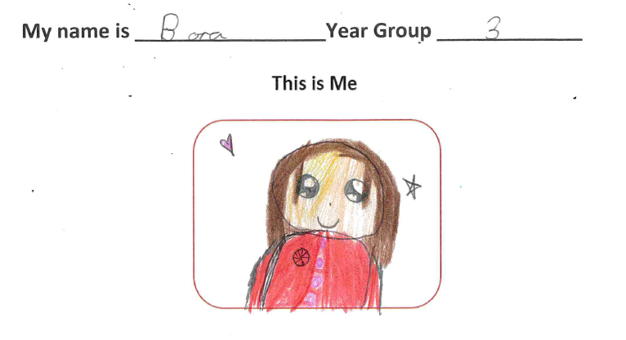
Why I wanted to be an EARA member?
I wanted to be an EARA member because I want my voice to be heard more and because I want to be kind and helpful to everyone.

